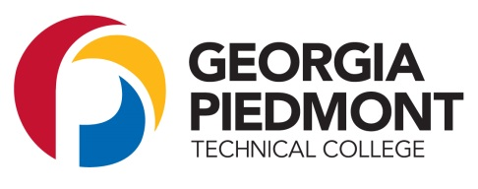

Student ID Number

|  |  |  |  |  |  |  |  |  |
| --- | --- | --- | --- | --- | --- | --- | --- | --- |
| **9** | **0** | **0** |  |  |  |  |  |  |

**2017-2018 BACHELOR’S DEGREE VERIFICATION**

Student Name: _____________________________________________

(Please print)

On your 2017-2018 FAFSA (Free Application for Federal Student Aid) you indicated that you will have your first Bachelor’s degree

before July 1, 2017 or will be working on a degree beyond a Bachelor’s degree.

Please complete the certification below:

 ____ I have not received a Bachelor’s Degree.

 ____ I received a Bachelor’s Degree from ______________________ on __________________.

(Name of college) (Month/Year)

 I declare all information on this form is true and correct to the best of my knowledge.

Student Signature: _________________________________________________

Date: ___________________________

Complete all sections and return this form to:

Clarkston Campus Covington Campus

Office of Financial Aid Office of Financial Aid

495 North Indian Creek Drive 16200 Alcovy Road

Clarkston, GA 30021 Covington, GA 30014

Fax: 404-294-6290 Fax: 770-784-2475